# **Planar Graph and Euler Graph**

**Planar Graph**

A graph is said to be planar if it can be drawn in a plane so that no edge cross.

**Example:** The graph shown in fig is planar graph.

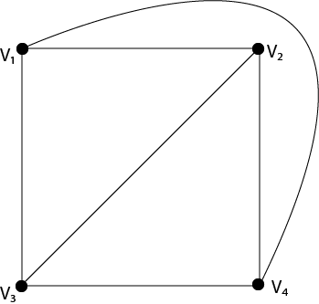  
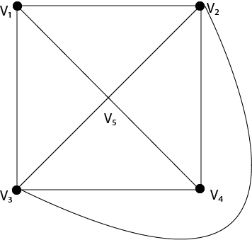

**Region of a Graph:** Consider a planar graph G=(V,E). A region is defined to be an area of the plane that is bounded by edges and cannot be further subdivided. A planar graph divides the plans into one or more regions. One of these regions will be infinite.

**Finite Region:** If the area of the region is finite, then that region is called a finite region.

**Infinite Region:** If the area of the region is infinite, that region is called an infinite region. A planar graph has only one infinite region.

**Example:** Consider the graph shown in Fig. Determine the number of regions, finite regions and an infinite region.

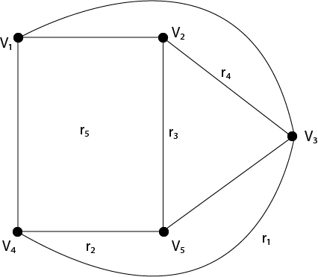

**Solution:** There are five regions in the above graph, i.e. r1, r2, r3, r4, r5.

There are four finite regions in the graph, i.e., r2, r3, r4, r5.

There is only one infinite region, i.e., r1

## Properties of Planar Graphs:

1. If a connected planar graph G has e edges and r regions, then
2. If a connected planar graph G has e edges, v vertices, and r regions, then v-e+r=2.
3. If a connected planar graph G has e edges and v vertices, then 3v-e≥6.
4. A complete graph Kn is a planar if and only if n<5.
5. A complete bipartite graph Kmn is planar if and only if m<3 or n>3.

**Example:** Prove that complete graph K4 is planar.

**Solution:** The complete graph K4 contains 4 vertices and 6 edges.

We know that for a connected planar graph 3v-e≥6. Hence for K4, we have 3x4-6=6 which satisfies the property (3).

Thus K4 is a planar graph. Hence Proved.

## Non-Planar Graph:

A graph is said to be non-planar if it cannot be drawn in a plane so that no edge cross.

**Example:** The graphs shown in fig are non-planar graphs.

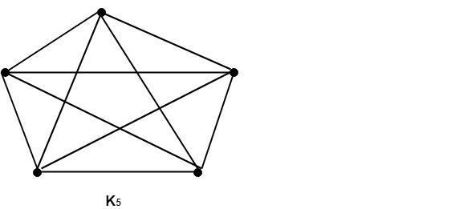

These graphs cannot be drawn in a plane so that no edges cross hence they are non-planar graphs.

## Properties of Non-Planar Graphs:

A graph is non-planar if and only if it contains a subgraph homeomorphic to K5 or K3, 3

**Example1:** Show that K5 is non-planar.

**Solution:** The complete graph K5 contains 5 vertices and 10 edges.

Now, for a connected planar graph 3v-e≥6.

Hence, for K5, we have 3 x 5-10=5 (which does not satisfy property 3 because it must be greater than or equal to 6).

Thus, K5 is a non-planar graph.

**Example2:** Show that the graphs shown in fig are non-planar by finding a subgraph homeomorphic to K5 or K3, 3.

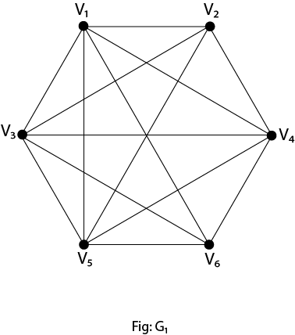

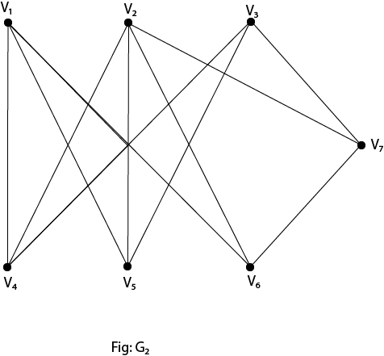

**Solution:** If we remove the edges (V1, V4), (V3, V4) and (V5, V4) the graph G1, becomes homeomorphic to K5. Hence it is non-planar.

If we remove the edge (V2, V7) the graph G2 becomes homeomorphic to K3, 3. Hence it is a non-planar.

**More examples:**

The planar graph with vertex as = 1, that is, the graph with the number of vertex as equal to zero, is shown as below:

  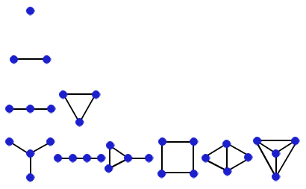  
 

Similarly, we can see that the planar graphs with the number of vertexes equal to 2, or 3 or 4, can be drawn as shown above. Note that all of the above graphs are planar, as none of them have any two edges crossing any one edge.

A graph G = (v, e) (as vertices and edges) is a drawing which maps each vertex u belonging to v to a point e(u) in a two dimensional space, and it’s a mapping of each edge ux belonging to e, making a path with its end points as e(u) and e (x). This graph is a planar graph if it can be made without any crossing over its edges.

Thus, a planar graph G, which is embedded in a plane, divides the pane into some different spaces, which is known as the faces of G. we denote the number of vertices of a graph G by v, the number of edges of a graph G by e and the number of faces of a graph G by f.

**Some of the examples of planar graphs are the graph of**

**a)** a tetrahedron, denoted as K4,   
**b)** the graph of K2, 5, and   
**c)**a cube, denoted as Q3, whose graph are shown as below:

* 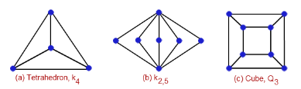

These are the most important examples of a planar graph as they are used for solving other complex problems base on planar graph theory.

A non planar graph is a graph, which can have any number of crossed edges with each other.

**For example:**

The following are some of the examples of non-planar graphs:

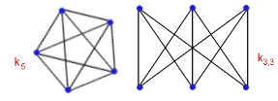

Note that the above two non-planar graphs make the core or base for the planar graph theory as many properties and theorems depends on the above two non-planar graphs. Hence, it is very much required to understand in great depth about the structure and drawing of these above two non-planar graphs.

**Some of the other higher order examples of planar graphs like:**

a) a octahedron (has 8 faces, 6 vertices and 12 edges).  
b) a dodecahedron (**has 12 faces, 20 vertices and 30 edges).**  
c) an icosahedron (20 faces, 12 vertices and 30 edges). Are shown as below:

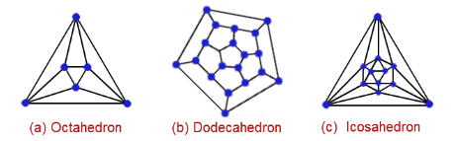

## Graph Coloring:

Suppose that G= (V,E) is a graph with no multiple edges. A vertex coloring of G is an assignment of colors to the vertices of G such that adjacent vertices have different colors. A graph G is M-Colorable if there exists a coloring of G which uses M-Colors.

**Proper Coloring:** A coloring is proper if any two adjacent vertices u and v have different colors otherwise it is called improper coloring.

## Method to Color a Graph

The steps required to color a graph G with n number of vertices are as follows −

**Step 1** − Arrange the vertices of the graph in some order.

**Step 2** − Choose the first vertex and color it with the first color.

**Step 3** − Choose the next vertex and color it with the lowest numbered color that has not been colored on any vertices adjacent to it. If all the adjacent vertices are colored with this color, assign a new color to it. Repeat this step until all the vertices are colored.

**Example**

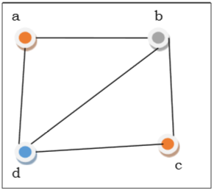

In the above figure, at first vertex a is colored red. As the adjacent vertices of vertex a are again adjacent, vertex b and vertex d are colored with different color, green and blue respectively. Then vertex c is colored as red as no adjacent vertex of c is colored red. Hence, we could color the graph by 3 colors. Hence, the chromatic number of the graph is 3.

**Example:**

Consider the following graph and color C = {r, w, b, y}. Color the graph properly using all colors or fewer colors.

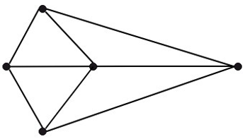

The graph shown in fig is a minimum 3-colorable, hence x(G)=3

**Solution:** Fig shows the graph properly colored with all the four colors.

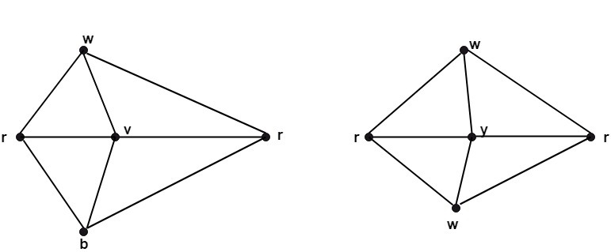

Fig shows the graph properly colored with three colors.

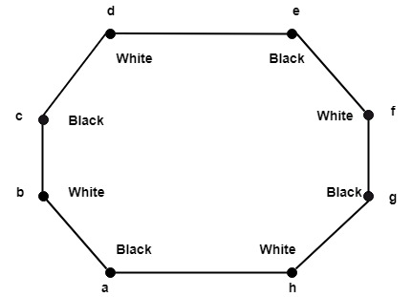

**Chromatic number of G:** The minimum number of colors needed to produce a proper coloring of a graph G is called the chromatic number of G and is denoted by x(G).

**Example:** The chromatic number of Kn is n.

**Solution:** A coloring of Kn can be constructed using n colours by assigning different colors to each vertex. No two vertices can be assigned the same colors, since every two vertices of this graph are adjacent. Hence the chromatic number of Kn = n.

## Applications of Graph Coloring

Some applications of graph coloring include:

* Register Allocation
* Map Coloring
* Bipartite Graph Checking
* Mobile Radio Frequency Assignment
* Making a time table, etc.

## State and prove Handshaking Theorem.

**Handshaking Theorem:** The sum of degrees of all the vertices in a graph G is equal to twice the number of edges in the graph.

Mathematically it can be stated as:

              ∑v∈Vdeg(v)=2e

**Proof:** Let G = (V, E) be a graph where V = {v1, v2, . . . . . . . . . .} be the set of vertices and E = {e1,e2 . . . . . . . . . .} be the set of edges. We know that every edge lies between two vertices so it provides degree one to each vertex. Hence each edge contributes degree two for the graph. So the sum of degrees of all vertices is equal to twice the number of edges in G.

Hence,         ∑v∈Vdeg(v)=2e

Euler Graph and Euler's Theorem

Euler Path:

A Euler Path through a graph is a path whose edge list contains each edge of the graph exactly once.

**Euler Circuit:** An Euler Circuit is a path through a graph, in which the initial vertex appears a second time as the terminal vertex.

**Euler Graph:** An Euler Graph is a graph that possesses a Euler Circuit. A Euler Circuit uses every edge exactly once, but vertices may be repeated.

**Example:** The graph shown in fig is a Euler graph. Determine Euler Circuit for this graph.

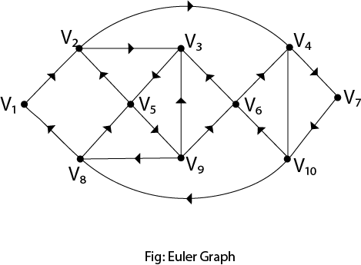

**Solution:** The Euler Circuit for this graph is

              V1,V2,V3,V5,V2,V4,V7,V10,V6,V3,V9,V6,V4,V10,V8,V5,V9,V8,V1

We can produce an Euler Circuit for a connected graph with no vertices of odd degrees.

State and Prove Euler's Theorem:

**Statement:** Consider any connected planar graph G= (V, E) having R regions, V vertices and E edges. Then V+R-E=2.

**Proof:** Use induction on the number of edges to prove this theorem.

**Basis of Induction:** Assume that each edge e=1.Then we have two cases, graphs of which are shown in fig:

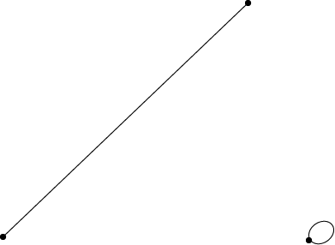

In Fig: we have V=2 and R=1. Thus 2+1-1=2

In Fig: we have V=1 and R=2. Thus 1+2-1=2.

Hence, the basis of induction is verified.

**Induction Step:** Let us assume that the formula holds for connected planar graphs with K edges.

Let G be a graph with K+1 edge.

Firstly, we suppose that G contains no circuits. Now, take a vertex v and find a path starting at v. Since G is a circuit free, whenever we find an edge, we have a new vertex. At last, we will reach a vertex v with degree1. So we cannot move further as shown in fig:

Now remove vertex v and the corresponding edge incident on v. So, we are left with a graph G* having K edges as shown in fig:

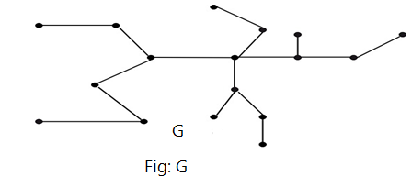

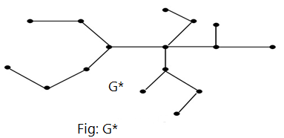

Hence, by inductive assumption, Euler's formula holds for G*.

Now, since G has one more edge than G*, one more vertex than G* with same number of regions as in G*. Hence, the formula also holds for G.

Secondly, we assume that G contains a circuit and e is an edge in the circuit shown in fig:

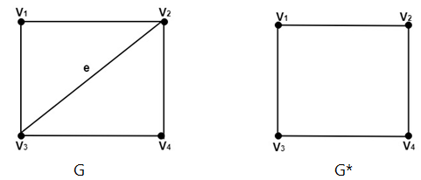

Now, as e is the part of a boundary for two regions. So, we only remove the edge, and we are left with graph G* having K edges.

Hence, by inductive assumption, Euler's formula holds for G*.

Now, since G has one more edge than G*, one more region than G* with same number of vertices as G*. Hence the formula also holds for G which, verifies the inductive steps and hence prove the theorem.